Clear epoxy casting resin
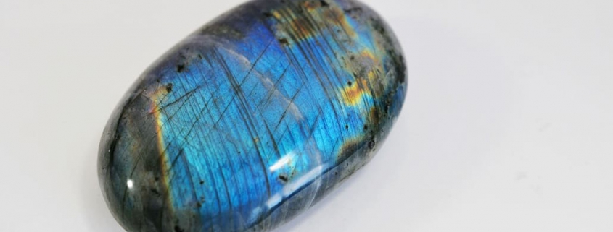

Clear epoxy casting resin for epoxy table, epoxy resin tops and more
Everyone has seen those tabletops decorated with embedded pennies, or the collections of resinated insects quietly waiting for their revenge in their shiny clear epoxy prison. It seems like everyone has a clear epoxy resin craft project in the works. Whether it is a river or penny tabletop, resin jewellery, embedded objects and paperweights, or as a glossy varnish for an artwork, do not be put off by the apparent trickiness of two part epoxy resin crafts. Two part epoxy casting resin kits take the trouble out of the whole process, providing you with simple step-by-step instructions and advice for the experienced and newbies alike.
Below we take a look at some of the exciting things you can do with clear two part epoxy resin, and some of the tips and tricks to get your project right first time.

Water clear casting resin for impressive crafts
Once cured, epoxy casting resin is so flexible and versatile it can be hard to know where to start. We have collected some of the top clear epoxy resin craft projects to inspire you with your own.
Two part epoxy resin is perfect for moulding jewellery, decorative items, paperweights, plus whatever you can think of!

Inspiration for casting with epoxy resin: jewellery, paperweight, serving tray
One of the joys of epoxy resin casting is that if you can make the mould (the negative) for it, you can make it (the positive). When it comes to resin jewellery, you can use dyes to make colourful bangles, pendants, bangles, brooches, rings, earrings or anything you can think of. For an added personal touch, you can include flowers, images, coins, buttons, beads, cogs, bugs, feathers… In the Victorian era, mourning jewellery included locks of hair. It’s up to you!
If jewellery is not your thing, look around you. Do you need a paperweight, coasters, is your serving tray coffee stained and in need of a do-over? You can do all of these with clear epoxy resin. Maybe your drawers have old or mismatched doorknobs and handles? You can resin cast some new ones with your own unique style. Christmas tree decorations, pendants and light catchers, resinated insects, trinket bowls, there is a reason that clear epoxy casting has taken crafting by storm.
Updating a tired tabletop or countertop is a common project, and one seemingly ready made for epoxy. Epoxies can be used to give a worktop a smooth, glossy finish that is also scratchproof and incredibly hard wearing. You can include dyes in your epoxy if you want to add some extra drama.
Penny countertops have been all the rage over the past few years, and inclusions like this under an epoxy makes for a glossy and interesting surface. It doesn’t have to be pennies, you can use art, photographs, make some hard wearing decoupage, maps, the sky is the limit! For a more advanced option, river tables run epoxy through them to look like a river, but this is not a job for a first timer.

Using clear epoxy resin – sealing for long lasting artwork and photographs
Clear epoxy is perfect for using as a sealant for artworks or photographs. It provides a clear, glossy, smooth and level surface that will protect the underlying piece from all those elements that will damage them over time – moisture, sunlight, sticky fingers, the bumps and knocks of life.

Epoxy resin: tips
Here are some important things to remember when using clear epoxy resin, for example epoxy mixing tips:
- Do a test run beforehand– don’t just dive straight on in unless you are experienced enough with the product to understand exactly how to mix and apply it.
- Make sure that all tools are clean – dust and other contaminants will muddy your epoxy, damaging that clear shine.
- Mix resin and hardener thoroughly without whipping! Introducing air bubbles into the epoxy will make more work later when you have to make sure they are all removed from the final finish.
- Do not leave the epoxy in the mixing container while you go to make a coffee – it sets very quickly and you may come back to a solid unusable lump. In fact, don’t eat or drink at all while handling the epoxy resin!

Which is the best resin to buy?
Not all casting resins are created equal, and there are a number of things to look out for when you purchase. Try to choose a clear epoxy resin that is:
- Non-hazardous and non-toxic – Epoxies are available in varying grades of heavy duty-ness. For craft projects you should look for the resins that have no or low VOC, low odour, and are certified non-toxic.
- UV stabilised and non-yellowing – Epoxies have a tendency to yellow or chalk in sunlight. Choose an epoxy with UV stabilisers to keep the clear glossy appearance.
- Fast curing – Nobody wants to wait days for their project to cure. Look for fast-curing products to speed up the process.
- Easy mixing ratio – Epoxies are two part chemicals, containing of the epoxy resin as a base and the hardening part. The resin requires a catalyst/ hardener to begin the hardening and curing process. Some kits will have simple 1:1 resin to catalyst ratio which make the job far easier than if you have to work out a 17:4 mixing ratio.
- Shrinkproof – All resins shrink as they dry; the question is how much do they shrink. Heavy shrinkage can give a puckered appearance and ruin the smooth line of your coating or casting. So, go for max. 3% shrinkage.

