Epoxy Resin River Table with Wood step by step tutorial
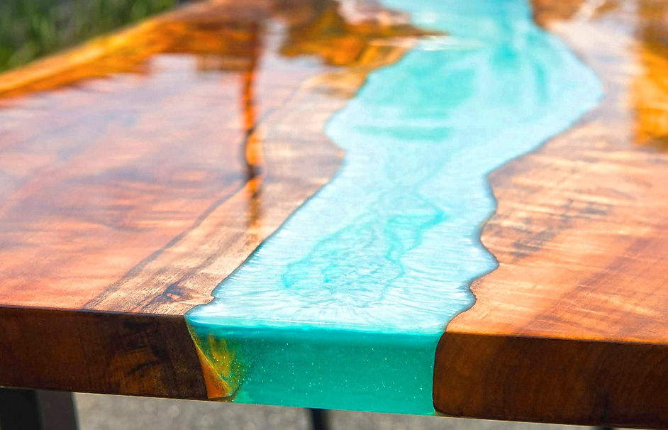

In this tutorial we will show you step by step how you can make a stunning and exclusive epoxy resin table from wood yourself. With the right technique, this isn’t as difficult as it might seem at first. In this article we will show you exactly and in detail how this works and I will tell you some valuable professional tips. A well-done table is of course only possible with the right material and equipment. That’s why you’ll also find a list of what you need to make an Epoxy River Table.

What’s an Epoxy River Table?
An Epoxy River Table is a hybrid furniture, made out of wooden planks and Resin in between. Often the blanks have natural edges, the containing Resin Epoxy between looks like a flowing river.
The idea and the trend of the so-called Epoxy River Tables comes from the USA like so many others. In the last years a real epoxy resin table fever has broken out all over the world. Because these tables are very modern but at the same time also extremely noble and high-quality. In addition, they are real eye-catchers and radiate an exotic beauty.
Above all, the Epoxy River Tables create a very exciting contrast through the combination of wood and mostly dyed resin and are therefore extremely appealing for most people. The special thing about these pieces of furniture made of wood and resin, however, is that they cannot be assigned to any style direction and appeal to very different furnishing styles. Both lovers of wood furniture and people who prefer the modern style are equally addressed by this type of epoxy table.
There are no limits to creativity in the crafting of an Epoxy Table: from the most exotic variants with vivid colours and structures and extravagant design to more conservative, clean designs, with neutral or more transparent colours, almost anything is possible.
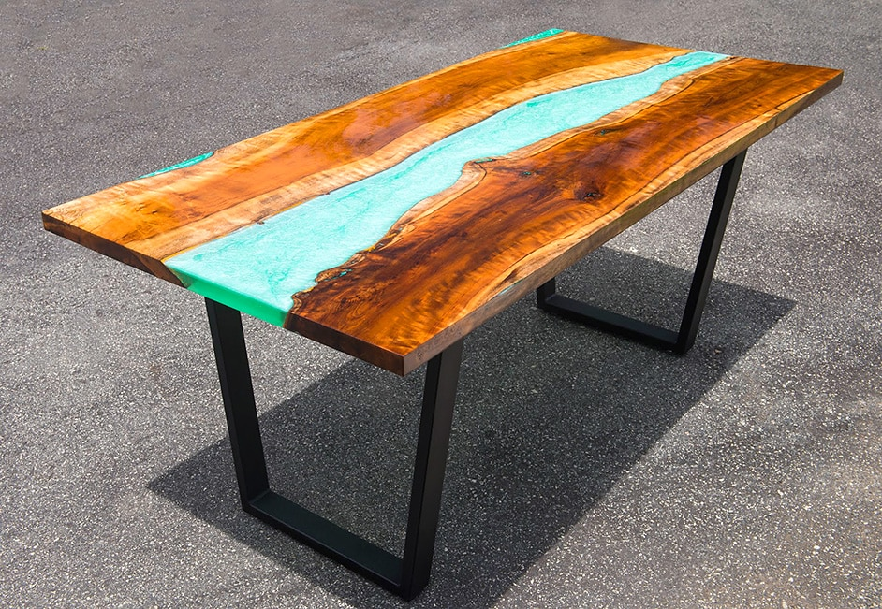

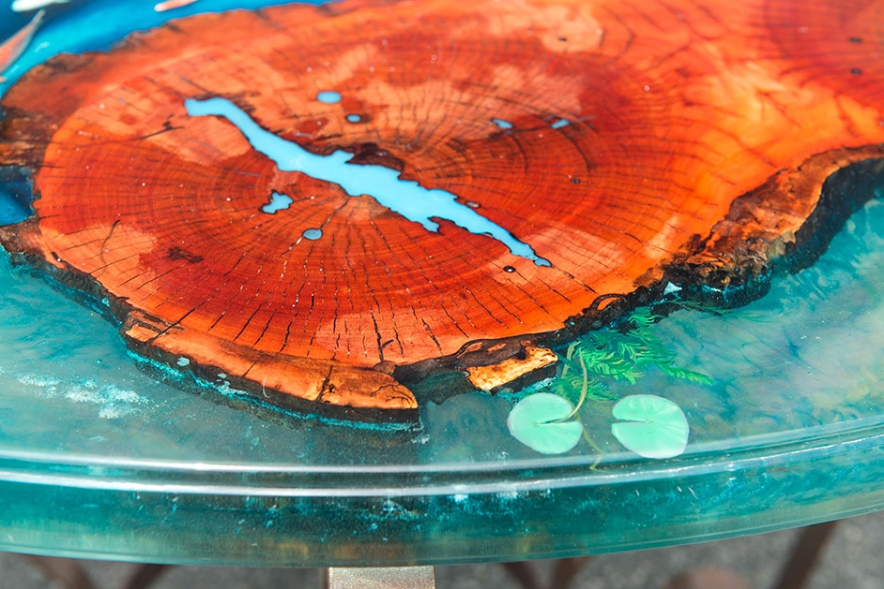

Supplies you Need for a Resin Wood Table

Dry wood carefully: The most important thing is that the wood you want to use is sufficiently seasoned or properly dried. (ideally less than 12%)
Saw it: The wooden panel is cut lengthwise in half with a circular saw in the middle. If you do not have a circular saw, have the carpenter do this. Both pieces of wood must then be cut to exactly the same length and the side edges cut at right angles to the straight long sides. This is also done with a circular saw. If you do not have this equipment, have the carpenter do this.
Planing: With a planing machine you make sure that the two wooden parts have an even thickness and the absolutely necessary flatness. If you do not have a planer, ask your wood supplier or carpenter to plane the wood.

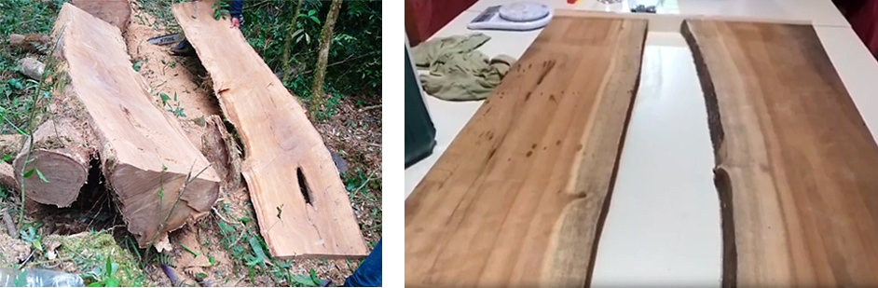

Working Conditions to build your epoxy wood table:
A dry, dust-free workshop environment or garage heated in winter is highly recommended for this work. It is also important to work in a well ventilated area. It is important to maintain a stable workshop temperature of ideally 20°C or more during set-up and throughout the curing time of the resin. Do not work in cold, humid or hot conditions as this will affect the performance, drying and appearance of the resin – this could ruin your epoxy wood table.
Tip: Do not store the epoxy resin on the floor as the floor is always colder than the room. Even if you have the perfect temperature of around 20 C degrees, the floor will not be more than 15 C to 17 C degrees. If the resin is too cold, tiny bubbles will form which you can hardly get out of the resin, not even with a heat gun.

Bark Removal and Grinding
- Although the bark on the wood always looks very attractive, it must always be thoroughly removed. Then you should sand the edges thoroughly by hand. This will allow the epoxy resin to bond better with the wood later. Use a chisel or similar to carefully remove the bark.
- Then you have to sand all the wood. Start with 80 to 220 grains and remove the dust after each grain. As already mentioned, you can sand the sides by hand with sandpaper. An orbital sander is well suited for the surfaces.
- Afterwards you should remove the sanding dust from the wood very thoroughly. It is best to use a vacuum cleaner and a microfibre cloth to wipe off any dust residue.

- All cracks, porous and uneven areas in the wood should be filled with epoxy resin. Use crystal clear resin without pigment. If the irregularities are on the edges, you can seal the edges with a stable adhesive tape before sealing, so that the resin does not run off over the edges.
- When the filled cracks and the like are completely cured, you should seal all the wood with resin. For this you also use a crystal clear resin with which you generously coat all the wood, including the surfaces, with a brush. The sealing prevents the wood from gassing out later. Remember to let it dry thoroughly after sealing (depending on the resin, at 18°C to 24°C for at least 5 hours). As soon as the whole thing is completely cured, the edges – where the wood later comes into contact with the cast resin (also called “river”) – should absolutely be roughened with sandpaper. The resin will then bond better with the edges.
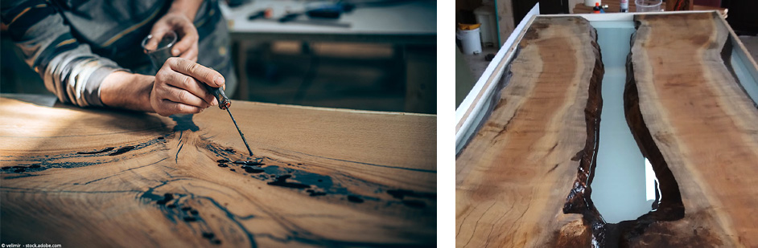

Build your Mould for the Resin Tabletop
- In order to be able to cast the epoxy resin, a mould is assembled from MDF boards in the length of your wood and in the size of the desired tabletop. The preparation is not difficult, but some care must be taken and accurately measured. For the shape you use 15mm MDF boards on the bottom and sides at pray. The side panels should be about 10 mm higher than the actual tabletop. The side panels are fastened to the underside with screws or alternatively glued together with hot glue.
- Then it is best to use clear sanitary silicone to seal the edges. Here you should work very exactly and not forget anything, the form must be 100% tight.
- A very important step now is to apply a release agent into the finished mould. You can either glue the mould completely with tape (Ducktape) or use liquid release wax. Alternatively you can spray the mould with silicone spray or Teflon spray. With silicone spray it is advisable to apply up to three layers. The use of a release agent is very important for later removal of the tabletop, as otherwise the resin would adhere to the MDF and the parts of the mould would be very difficult to remove from the resin table.
- It is also essential that the substrate or work surface where the mould is placed is absolutely in balance. Otherwise, the resin would become crooked and leak later.
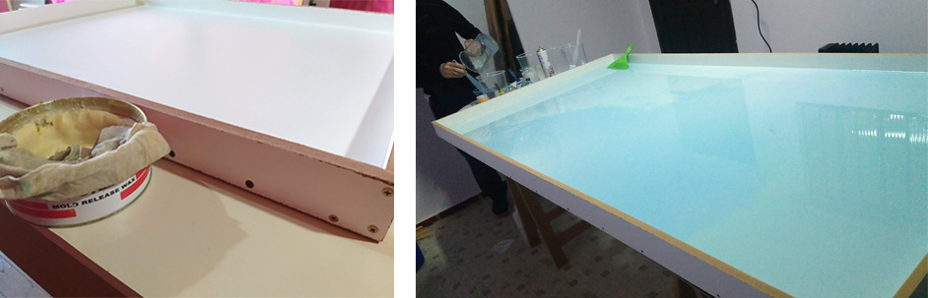

Fixing the Wood into the Mould
- After the mould is finished, you can insert the wood. Push the wood into exactly the position you want it in the finished table and fix it well with several parallel clamps. For smaller tables, you can weigh down the wood with bricks, for example. Note, however, that all devices or parts used to fasten the wood can come into contact with the resin.
- It is highly recommended that you apply a sanitary silicone barrier to the wood along the edge of the river. However, you should not pull the barrier too close to the edge – keep a distance of 0.4 to 0.8 inch so that the resin is poured in cleanly. With such a barrier you prevent the resin from spreading over the whole table.
- 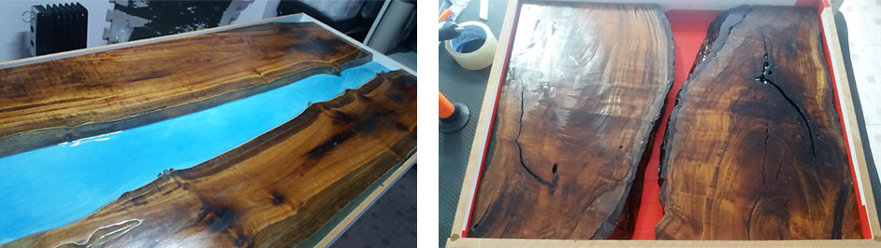

Mixing Epoxy Resin
- Once you are working with the resin, be sure to wear nitrile gloves, goggles and respiratory protection first.
To mix the resin, use a sufficiently large bucket. It is best to use a bucket that is large enough for the total amount of resin or the first layer of resin.
- Depending on the resin manufacturer, it may be necessary to cast the resin in layers. This is because resin has the property of becoming extremely hot and boiling at a certain thickness. If the resin boils, it is immediately unusable or becomes cloudy. Of course, how many layers are needed depends not least on the thickness of your tabletop. In any case, you should pay attention to the maximum layer thickness (see manufacturer’s instructions
- Make sure that you stick to the mixing ratio recommended by the manufacturer and that the resin components mix very well. It is best to use a drill with a mixer. This is the only way to ensure optimal mixing of the components.
- Once you have finished mixing, you can remove the air bubbles in the resin with a heat gun or a butane torch. However, please only torch as much as necessary or swing over it briefly with the heat gun, otherwise the resin could be damaged.

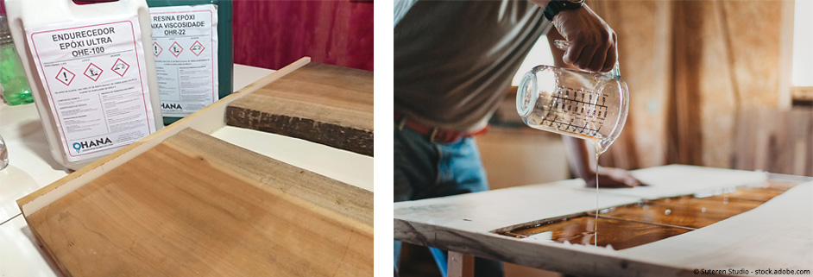
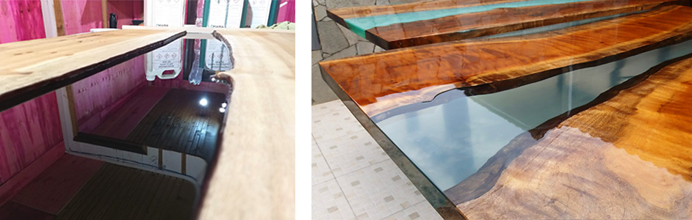

Coloring the Resin and Pouring a Water Effect
- Once the two resin components are mixed, you can optionally add pigments of your choice.
- For this typical water look, fill your resin into two different containers, e.g. in a ratio of 1 : 1.5. Colour the smaller proportion of resin with a matt blue pigment and the larger with a turquoise metallic pigment. Of course, you can also use other colours according to your taste.
- Now pour both containers simultaneously from one side or alternately into your mould. For a successful water effect, make light circular movements with the container while pouring, especially with the metallic pigment.
- Once you have completely poured everything into the mould, you can use a wooden stick or similar to change or reinforce the pattern in the resin as you wish.
- Then let everything harden well according to the manufacturer’s instructions.
- 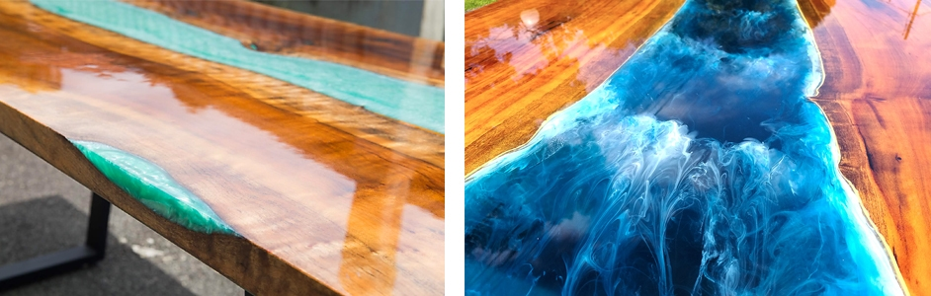

ResinTint - Liquid Pigment - 10 Pack
- Tint epoxy resin to create flow art paintings or marbled effects with ease.

River Table with Crystal Clear Resin and optional Embedded Objects
- Pour the first layer of crystal clear resin into the epoxy resin quickly but carefully, and then briefly apply the epoxy resin with a heat gun. Never heat the resin in one place for more than 3 seconds, as this can lead to steaming or burning of the resin and the end result may be a yellowish epoxy.
- The second casting takes place in the so-called “B Stage”. At this point, the first layer is not yet completely cured and still sticks. If you lightly touch it with the glove, the resin should no longer be liquid, but should feel as if you are touching the inside of an adhesive tape. This means that it is ready for the second pour. DO NOT wait any longer, otherwise the second layer may not bond optimally with the first. If you missed this point, wait until the resin is completely cured, then lightly sand it with 220 grain, clean the surface and then pour the second layer.
- If you now want to embed objects like pebbles, crystals or other things, you should also do so in the B-Stage. Please do not do this before, otherwise the stones will sink to the bottom.
- Now pour the second layer of resin just above the edge.
- Let the resin cure completely – be sure to follow the manufacturer’s instructions exactly.

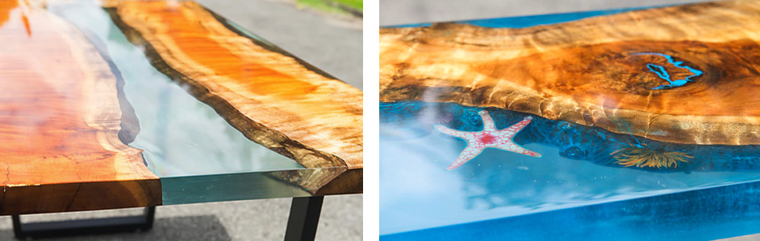

Demoulding the Epoxy Resin Tabletop
- Loosen any screws on the mould and remove the parallel clamps. Separate the mould from the cast tabletop using a plastic hammer and chisel. Carry out this step carefully so that your tabletop is not damaged.

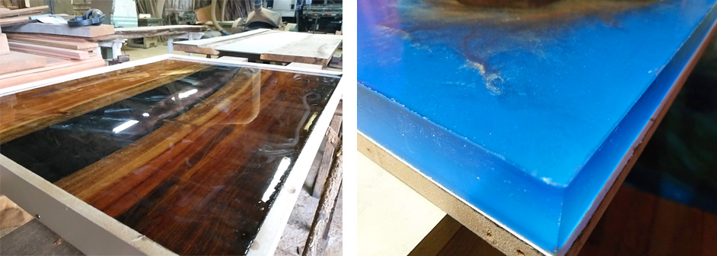

Sanding your Tabletop
- After you have removed the plate from the mould, it is time to sand the tabletop. The easiest way is with an eccentric grinder. Of course you can also do this by hand, the important thing is that no resin is visible on the wood. Start with grain 80 to grain 400.
- Optionally, you can also perfectly smooth the edges of your tabletop with a router before sanding or, if necessary, cleanly trim or plane them again with a circular saw.
- Tip: The lighter the desired surface, the finer you should grind, so the higher the grain size.

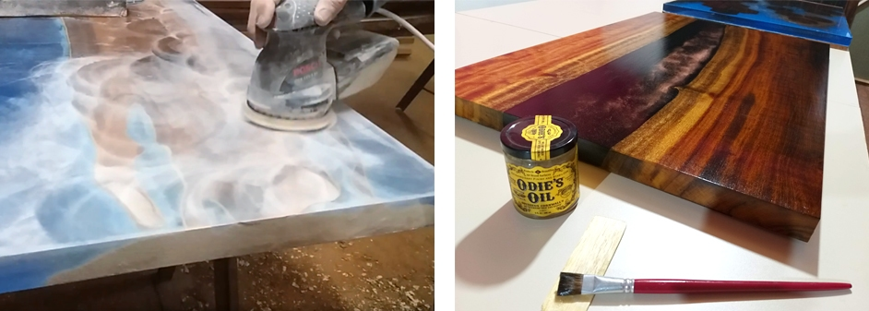

Finishing

- Resin Tabletop Polishing
- Before you can apply a finish on your resin tabletop, you should polish the table. This will help to get rid of the little scratches you have in your epoxy because of the sanding process. For bigger surfaces like tabletops, we recommend you to use a buffing machine for the best result. For smaller projects you also could use a towel and polishing compound to polish it by hand.
- Tabletop Oiling
- The simplest way for the finish is to oil the tabletop to protect the wood. By oiling, you give the surface a smooth appearance with less shine, but a natural feel.. It seals the wood and gives it a natural touch. Moreover, with this oil only one application is necessary and you don’t have to oil after.
- It is best to apply the oil evenly with a soft cloth onto the entire tabletop. Before you oil the tabletop, however, you should polish it – especially the resin River – with a polishing machine and polishing paste. This is to remove any traces of sanding and to achieve a silky surface.

- 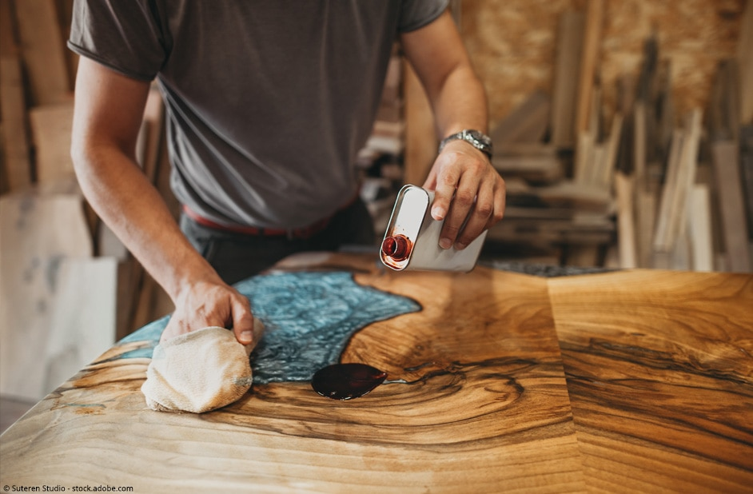

Clear Resin Coating your Tabletop
- A DIY variant for a shiny surface of your tabletop is to coat it with crystal clear resin. Start with the underside of the tabletop. Apply a sturdy tape 0.4 to 0.8 inch overhanging on all four sides. This now acts as a barrier to prevent the resin from dripping unevenly across the sides.
- Pour the resin over the surface and spread it evenly over the entire surface with a plastic spatula. To avoid bubbles, torch the resin briefly with a heat gun. Allow the resin to cure completely.
- We recommend you to cast a second layer of resin, the first one serves only as a base. For this you should sand the first layer beforehand so that the layers bond optimally with each other.
- When everything is well cured, remove the tape. Now stick the lacquered underside at least 2 inch wide along the edge.
- Turn the tabletop over and underlay it with something suitable, e.g. wood scraps. Make sure that the tabletop is 100% in balance and that the already painted underside is not damaged. In addition with a fleece or similar underlay is therefore recommended.
- Now pour the resin over the top of the table including the table edges and distribute it evenly with the spatula. Let everything harden well and then remove the adhesive tape.
- Finally sleep off any sharp edges on the underside with a fine sandpaper.
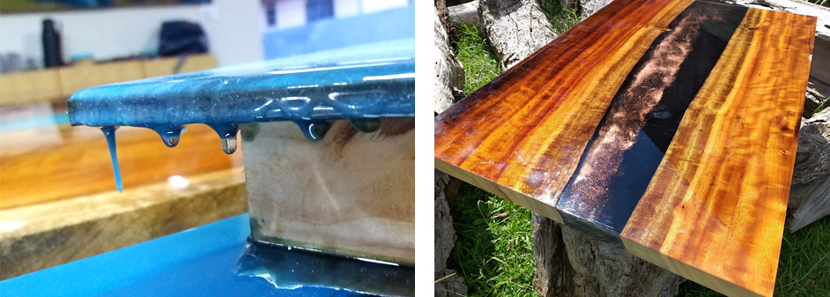

Polyurethane Coating
- A 100% perfect hight glossy varnish is only possible with a polyurethane coating. For this type of coating however, a painting booth, special equipment plus the right technology and know-how are required. This type of coating can only be carried out by a professional and is quite expensive. But then this finish is absolutely perfect and very noble. So you give your table an impressive, mirror-smooth surface and in addition the tabletop is then very durable and well protected against external influences as for example scratch marks.

